INDEX
Sl No | Experiment | Page No. | Date
1 | Write a user defined function in python to:  - SHIFT(lst) that would accept a list as argument .The function should shift the negative numbers of the list to right and the positive numbers to left without using a another list.  For example if list initially contains  [3, -5, 1, 3, 7, 0, -15, 3, -7, -8]  Then after shifting list should contain  [3, 1, 3, 7, 0, 3, -8, -7, -15, -5]  - SwapHalfList(Array), which accepts a list Array of numbers and swaps the elements of 1st Half of the list with the 2nd Half of the list ONLY if the sum of 1st Half is greater than 2nd Half of the list.  Sample Input Data of the list:  Array= [ 100, 200, 300, 40, 50, 60]  Output  Arr = [40, 50, 60, 100, 200, 300]  - RShift(Lst) in Python, which accepts a list Lst of numbers shifts all its elements right once.  Sample Input Data of the list:  Lst= [ 10,20,30,40,12,11]  Output:  Lst = [ 11,10,20,30,40,12]  - LShift(Lst,n) in Python, which accepts a list Lst of numbers and n is a numeric value by which all elements of the list are shifted to left.  Sample Input Data of the list:  Lst= [ 10,20,30,40,12,11], n=2  Output:  Lst = [30,40,12,11,10,20]  - lst_reverse() that reverses a list. Write the code without slicing/built-in function.  Sample list: [12,34,5,67,43] After execution of the code: [43, 67, 5, 34, 12]  - part_reverse(lst,start, end) to reverse elements in a list where arguments are start and end index of the list part which is to be reversed.  Assume that, start<end, start>=0 and end<len(list)  Sample Input Data of List:  my_list=[1,2,3,4,5,6,7,8,9,10]  Function Call = part_reverse(my_list,3,6)  Output is  my_list=[1,2,3,7,6,5,4,8,9,10]  - lst_modify() to read a list of elements. Modify this list so that it does not contain any duplicate elements i.e. all elements occurring multiple times in the list should appear only once.  - swap_loc() to swap elements at the even location with the elements at the odd location.  Sample Input Data of the list:  Array= [ 100, 200, 300, 40, 50, 60]  Output  Array=[200,100,40,300,60,50]
2 | Consider the following student data:  data = [ ["Alice", 101, [85, 78, 92, 89]], ["Bob", 102, [76, 85, 90, 80]],  ["Charlie", 103, [92, 88, 94, 91]], ["David", 104, [60, 72, 70, 65]],…..]  Write Python user defined functions to:  - Calculate and display each student's average marks.  b) Identify and display the students who have scored below 70 in any subject.
3 | Write a user defined function that simulates a dice roll. The program should generate and display a random number between 1 and 6 (inclusive) each time it is run. Use the random module. Run the program 15 times and count and display how many times each number (1–6) appears.
4 | Consider the following:  emp = {"John": { "January": 4500, "February": 5200, "March": 4800 },  "Emily": {"January": 6000,”February": 6200,"March": 5800 },…..}  Write Python user defined functions to:  - Increase the sales by 10% for employees whose average sales exceed 6000.  - Identify the month in which each employee had their highest sales(display name & month).  - Display the details of those employees whose name begin with a vowel.
5 | Consider the following data format:  {101:['Andrew',78],102:['Mark',99],103:['John',100],...}  Write user defined functions to:  - Create a dictionary with the roll number, name and marks of n students in a class.  - display the names of students who have marks above 75.
6 | Consider the table MYPET given below. Write a python functions to perform specified operation:  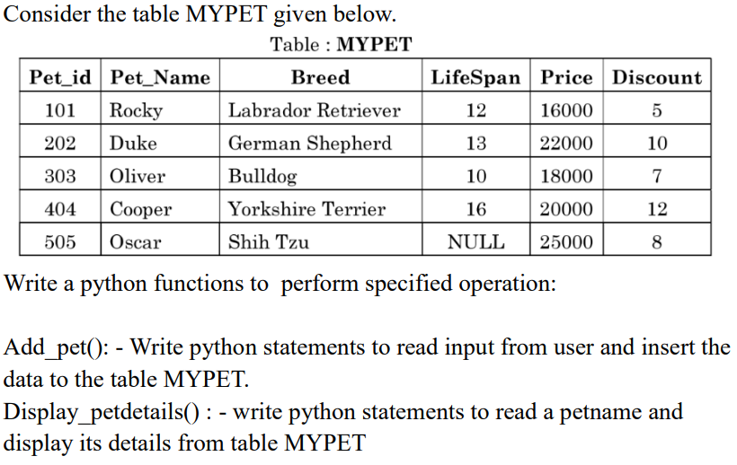  Create_Table() :- to create the table if doesn’t exist, otherwise with proper message.  Add_pet(): - to read input from user and insert the data to the table MYPET.  Display_petdetails(): to read a pet name from user and display its details from table MYPET if it exists in table, otherwise display an appropriate message.  Reduce_Price()-  -Reduces price by the discount whose discount is less than 5.  -Prints the number of rows updated.
7 | Write a program in python for Sql connectivity Consider tables emp and dept tables:  (a) Add a column HRA with default value 2000  (b) Modify HRA for the employee whose empno is input by the user.  (c) Display name, job and annual salary of employees whose comm is assigned in descending order of salary.  (d) Delete the record of employee whose employee number input by the user  (e) Display empno, name, job and department name who are either a manger or a clerk.  (f) Display minimum and maximum, sum and average of salary along with number of records in job  (g) Add record of the employee “Ford”
8 | Write functions for Python –Sql Connectivity:  (a) List tables in your database  (b) Create Tables – Garment & Fabric. (Tables given qstn 32)  (c)Display the structure of the table Fabric  (d) Insert a Record by accepting values from user  (e) Delete record of a garment with gcode accepted from the user  (f) Modify the price of a garment with specific gcode accepted from user.  (g) Display records of tables by choice -ie., either records of garment or fabric.
9 | A list of names is stored in a text file, Names.txt, (1 name per line) but it contains lot of duplicates. Create a Python function extract_unique_name( ) that extracts all unique names from the text file and stores them in a list and then print the names in alphabetical order.  Sample input file content:  Amithab  Sharuk  Deepika  Prabhas  amithab  DEEPIKA  Expected output:  ['amithab', 'deepika', 'prabhas', 'sharuk']
10 | Write a program with user defined functions  CreateWord(()- to create ‘word.txt’ file – by accepting n of lines of text from user and write it into file using writelines().  DisplayFile()- Display number of characters and number of words in it.
11 | Write a program with user defined functions  CreateStory()- n lines accepted from user in a text file story with few lines in it.  DisplayWord()- Display each word separated by a ‘#
12 | Write a program with user defined functions  CreatePledge()- to create pledge.txt, containing few lines of pledge.  DisplayPledge()- Display the contents line by line (after striping leading and trailing whitespaces) along with number of characters in each line
13 | Write a program with user defined functions  CreatePoem()- to create the file poem.txt containing the following :  The woods are lovely  dark and deep  But I have promises to keep  And miles to go before I sleep  And miles to go before I sleep (Note: all lines must be user input)  DisplayPoem()- displays the n most commonly occurring words.
14 | Write user-defined functions:  createText() – create the text file wisdom.txt with the following content.  My son, listen to your father's advice.  Don't turn away from your mother's teaching.  What they teach you will be like a beautiful crown on your head.  It will be like a chain to decorate your neck.  (Note: all lines must be user input)  NoVowels() reads the content of the file wisdom.txt and display those words that doesn’t contain any vowels in it.  vowelWord()- reads the content of the file wisdom.txt displays those lines which have the second letter of the first word a vowel.
15 | Write a program with user defined functions  - crtBookFile()- for entering details of books from user and insert it in a binary file named ‘book.det through list.  Sample: [Bookid, Bookname, Authorname, Price]  - BookPrice() –to display book details having price greater than a given price.  - SearchBook()- Sreach and display the details of a specific book entered by user
16 | Write a user defined function:  - MakeFile () to input multiple items from the user and add to binary file Items.dat which has structure as [Code, Description, Price].  - SearchRec(Code) in Python which will accept the code as parameter and search and display the details of the corresponding code on screen from Items.dat. Also display number items having such code out of total number of items.
17 | Write a program with user defined functions  - CreatEmp()- for entering details of employees from user and insert it in a binary file named ‘emp.dat’ through dictionary. Sample record has the form {empno:[empname,job, sal],  Sample: {101:[Mark,Manager,2000]}  b) DisplayEmps()-Display the records of all employees in tabular form.  c) SearchEmp()-display those employees’ details whose salary is between 25000 and 30000  d) SearchEmpno(eno)- accept the argument and display the record of the employee whose empno is input by the user.
18 | - A Binary file, CINEMA.DAT has the following structure:  {'MNO':'m101','MNAME':'Sound of Freedom', 'MTYPE':'Thriller']}  Where, MNO – Movie Number; MNAME – Movie Name; MTYPE is Movie Type  Write a user defined function:  createCinema(): that Adds records the user input data into the binary file.  findType(mtype): that accepts mtype as parameter and displays all the records from the binary file CINEMA.DAT, that have the value of Movie Type as mtype.
19 | A file, PASSENGERS. DAT, stores the records of passengers using the following structure:  [PNR, PName, BRDSTN, DESTN, FARE]  where:  PNR - Passenger Number (string type)  PName - Passenger Name (string type)  BRDSTN – Boarding Station Name (string type)  DESTN - Destination Station Name (string type)  FARE - Fare amount for the journey (float type)  Write user defined functions in Python for the following tasks:  - Create() - to input data for passengers and write it in the binary file PASSENGERS.DAT.  - SearchDestn(D) - to read contents from the file PASSENGERS.DAT and display the details of those Passengers whose DESTN matches with the value of D.  (iii) UpdateFare () - to increase the fare of all passengers by 5% and rewrite the updated records into the file PASSENGERS. DAT.  (iv) DeleteData() – to delete the details of a passenger whose PNR is input by user.
20 | - Order data (order_id, customer_name, order_date, total_amount) is stored in a binary file named Orders.dat. Each order is represented as a tuple. Help Simran complete the following tasks:  Write user-defined functions:  add_order() - to input order details from the user (order_id, customer_name, order_date, total_amount) and store them in "Orders.dat". The program should allow adding multiple orders until the user chooses to stop.  update_order_amount()- to modify the total_amount-for orders placed. The function should increase the total_amount of each qualifying order by 10%.
21 | - Consider book inventory using a CSV file named Inventory.csv.  The file structure is:  [BookID, Title, Author, Available]  where  BookID is an integer  Title and Author are strings  Available is an integer representing the number of copies available.  The librarian needs to write the following functions: -  - add_book(): This function accepts new book details from the user and adds them to `Inventory.csv`. The file should be created with column header if it doesn't exist.  - check_availability(book_id): This function takes a book_id as input and returns the number of copies available for that book. If the book is not found, it should return -1.
22 | - Assuming a CSV file students.csv has columns like student_id, name, class,div, subject, score and grade_level. Write the definition of functions to perform the following.  - Add_data( filename ) :- accepts a file name as argument and reads input from user and store data into the file as per format specified.  Display_data(filename) :- accepts a filename as argument and reads data from file. Function also reads subject name, class and div as input from user. Displays the average score by the student for the subject in the class specified.
23 | Anil created a csv file named gadgets.csv to store the details of the gadgets  The structure of gadgets.csv is:  [Deviceno, Name, Price, Brand] - Where, Deviceno is device ID (integer), Name is device name (string), Price is device price (integer), Brand is device brand (string)  He is now instructed to write the following functions to perform the required operations on csv files.  Newgadget() -to add the details of new gadgets in csv file gadget.csv which stores records in the format. Deviceno, name, price, brand. Get the input from the user.  Countgadget() - to read the csv file „gadget.csv‟ and display the details of the devices whose price in the range 1000 to 2500. Also, display the number of such devices.
24 | Samantha, a software developer at a company, is tasked with managing a database for employee performance reviews. She has created a CSV file named "Performance.csv" to store the data. The structure of "Performance.csv" is as follows:  [Emp_Id, Emp_Name, Project_Name, Review_Result]  Where:  Emp_Id - employee ID (integer)  Emp_Name - employee name (string)  Project_Name - name of the project for the performance review (string)  Review_Result - result of the review, which can be 'Excellent', 'Satisfactory', or 'Needs Improvement'  Samantha needs to implement the following user-defined functions to efficiently handle the data:  accept_record() - This function should accept a record from the user, including employee ID, employee name, project name, and review result, and add it to the "Performance.csv" file. The column headings should also be added on top of the CSV file.  excellent_count() - Samantha wants a function to count the number of employees who received an 'Excellent' review for any project. Help Samantha by providing Python code for these user-defined functions
25 | - Write a Python menu driven program to implement a stack (LIFO) using a list data structure.  A linear stack called Books contains the following information:  [BookNumber, name of the book and cost of the book]  - PUSH(Books,N) method in python to add N book details each containing the above mentioned information’s.  - DispStack()- display the stack content in same line  POP(Book)- pop and display all the elements of the stack and Under Flow when no more elements to be popped.
26 | A list of dictionaries contact contains the following information:  {Eid:[Ename, Phno,Salary]} of Employee  Write a Python menu driven program to implement a stack (LIFO) using a list data structure, stack status :  PUSH ( ) - To Push an object containing Phone number of Employee and Name of Employee into the stack.  POP( ) - To Pop an object from the stack and to release the memory  Display() – display details of all Employees
27 | Write a function in Python where Book is a stack implemented by a list of books:  (i) PushBook() - to add a new book entry as a record – ie. (book_no, book_title) of Books , considering it to act as push operations of the Stack data structure.  (ii) Disp_Stack() – display details of all books  Bookno: Booktitle one after other in different lines  (iii) PopBook() – display a record removed from the stack in the following format:  Bookno: Booktitle
28 | - Julie has created a dictionary containing names and marks as key value pairs of 6 students. Write a program, with separate user defined functions to perform the following operations:  ● PUSH(R)-Push the keys (name of the student) of the dictionary into a stack, where the corresponding value (marks) is greater than 75.  ● POP()- Pop and display the content of the stack with ‘Under flow’ message when there are no more elements to be popped.  For example: If the sample content of the dictionary is as follows:  R={"OM":76, "JAI":45, "BOB":89, "ALI":65, "ANU":90, "TOM":82}  The output from the program should be:  TOM ANU BOB OM Under flow
29 | - Andrew has a list containing 10 integers. You need to help him create a program with separate user defined functions to perform the following operations based on this list.  ● PUSHNums(N)- Traverse the content of the list and push the even numbers into a stack.  ● PopNums()- pop and display the content of the stack.  For Example: If the sample Content of the list is as follows:  N=[12, 13, 34, 56, 21, 79, 98, 22, 35, 38]  Sample Output of the code should be:  38 22 98 56 34 12 Empty Stack
30 | Write a function in Python, where Arr is a stack implemented by a list of numbers:  (i) PUSH(L), where L is a list of numbers. From this list push all numbers divisible by 5 into a stack implemented by using a list.  (ii) Display the stack if it has at least one element, otherwise display appropriate error  (iii) POP(), pop and returns top element when ever it is called, returns ‘UnderFlow’ if the stack is empty.
 | SQL
31 | Tables:- Garment and Fabric
32 | Table:- Student
33 | Tables:- EMP and Dept
34 | Tables:- Flights & Fares
35 | Tables:- Employee & Department

Exp No: 1 Date: 03-06-2026
Aim: Write a user defined function in python to
a) SHIFT(lst) that would accept a list as argument. The function should shift the negative numbers of the list to right and the positive numbers to left without using an another list.
For example, if list initially contains
[3, -5, 1, 3, 7, 0, -15, 3, -7, -8]
Then after shifting list should contain
[3, 1, 3, 7, 0, 3, -8, -7, -15, -5]
Source Code:
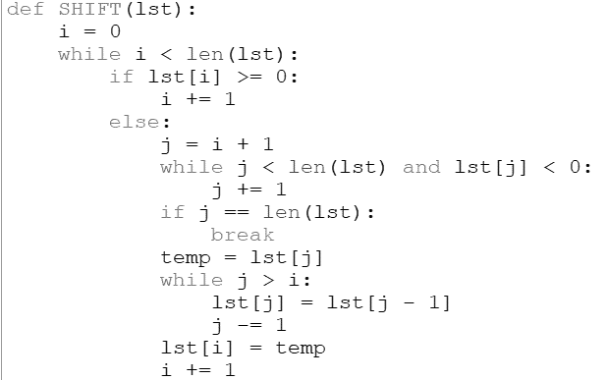

Output:

b) SwapHalfList(Array), which accepts a list Array of numbers and swaps the elements of 1st Half of the list with the 2nd Half of the list ONLY if the sum of 1st Half is greater than 2nd Half of the list.
Sample Input Data of the list:
Array= [ 100, 200, 300, 40, 50, 60]
Output
Arr = [40, 50, 60, 100, 200, 300]
SOURCE CODE:
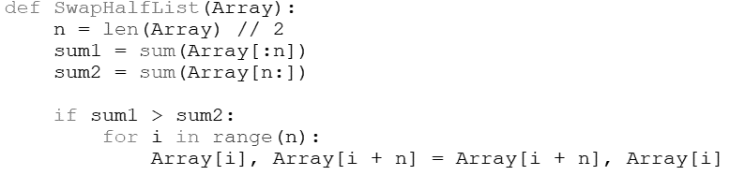
OUTPUT:
c) RShift(Lst) in Python, which accepts a list Lst of numbers shifts all its elements right once.
Sample Input Data of the list:
Lst= [ 10,20,30,40,12,11]
Output:
Lst = [ 11,10,20,30,40,12]
SOURCE CODE:
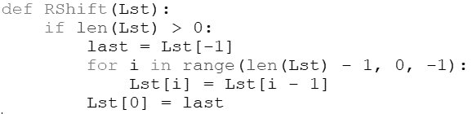
OUTPUT:

d) LShift(Lst,n) in Python, which accepts a list Lst of numbers and n is a numeric value by which all elements of the list are shifted to left.
Sample Input Data of the list:
Lst= [ 10,20,30,40,12,11], n=2
Output:
Lst = [30,40,12,11,10,20]
SOURCE CODE:
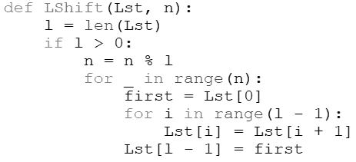
OUTPUT:
e) lst_reverse() that reverses a list. Write the code without slicing/built-in function.
Sample list: [12,34,5,67,43] After execution of the code: [43, 67, 5, 34, 12]

SOURCE CODE:
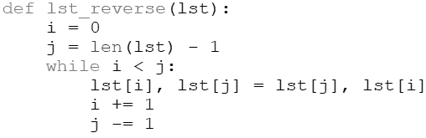
OUTPUT:
f) part_reverse(lst,start, end) to reverse elements in a list where arguments are start and end index of the list part which is to be reversed
SOURCE CODE:
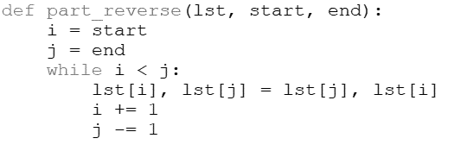
OUTPUT:
g) lst_modify() to read a list of elements. Modify this list so that it does not contain any duplicate elements i.e. all elements occurring multiple times in the list should appear only once.
SOURCE CODE:
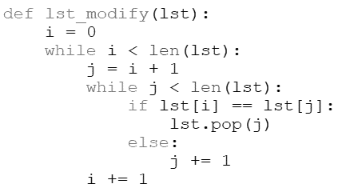
OUTPUT:

h) swap_loc() to swap elements at the even location with the elements at the odd location.
SOURCE CODE:
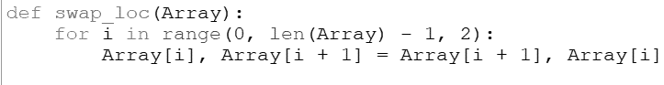
OUTPUT:

Exp No: 2 Date: 03-06-2026
Aim: Consider the following student data:
data = [ ["Alice", 101, [85, 78, 92, 89]], ["Bob", 102, [76, 85, 90, 80]],
["Charlie", 103, [92, 88, 94, 91]], ["David", 104, [60, 72, 70, 65]],…..]
Write Python user defined functions to:
a) Calculate and display each student's average marks.
b) Identify and display the students who have scored below 70 in any subject.
SOURCE CODE:
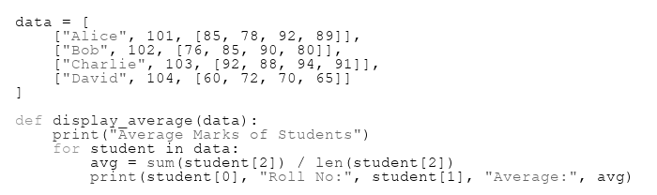
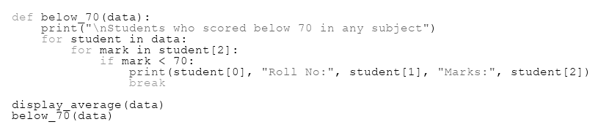
OUTPUT:
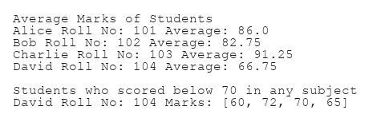
Exp No: 3 Date: 10-06-2026
Aim: Write a user defined function that simulates a dice roll. The program should generate and display a random number between 1 and 6 (inclusive) each time it is run. Use the random module. Run the program 15 times and count and display how many times each number (1–6) appears.
SOURCE CODE:
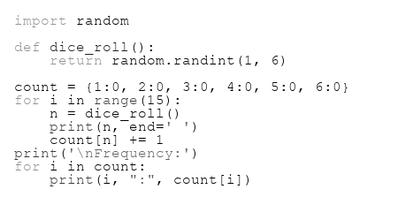
OUTPUT:
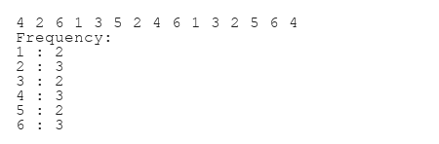
Exp No:4 Date: 10-06-2026
Aim: Consider the following:
emp = {"John": { "January": 4500, "February": 5200, "March": 4800 },
"Emily": {"January": 6000,”February": 6200,"March": 5800 },…..}
Write Python user defined functions to:
a) Increase the sales by 10% for employees whose average sales exceed 6000.
b) Identify the month in which each employee had their highest sales(display name & month).
c) Display the details of those employees whose name begin with a vowel.
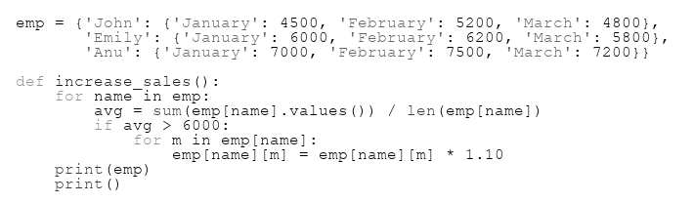
SOURCE CODE:

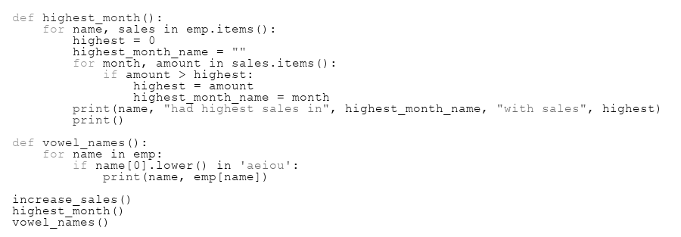
OUTPUT:
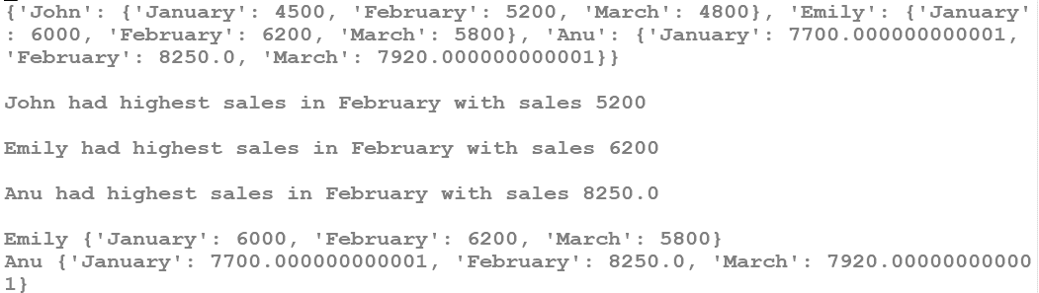
Exp No:5 Date: 10-06-2026
Aim: Consider the following data format:
{101:['Andrew',78],102:['Mark',99],103:['John',100],...}
Write user defined functions to:
a) Create a dictionary with the roll number, name and marks of n students in a class.
b) display the names of students who have marks above 75.
SOURCE CODE:
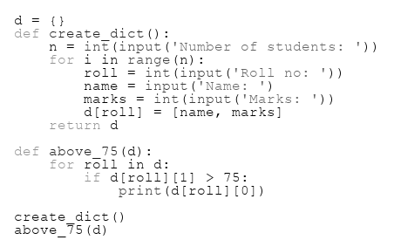
OUTPUT:
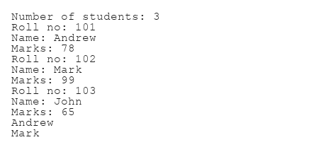
Exp No: 6 Date: 17-06-2026
Aim: Consider the table MYPET given below. Write a python functions to perform specified operation:
Create_Table() :- to create the table if doesn’t exist, otherwise with proper message.
Add_pet(): - to read input from user and insert the data to the table MYPET.
Display_petdetails(): to read a pet name from user and display its details from table MYPET if it exists in table, otherwise display an appropriate message.
Reduce_Price()-
-Reduces price by the discount whose discount is less than 5.
-Prints the number of rows updated.
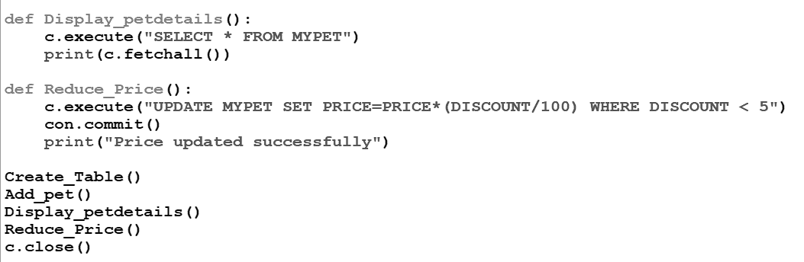
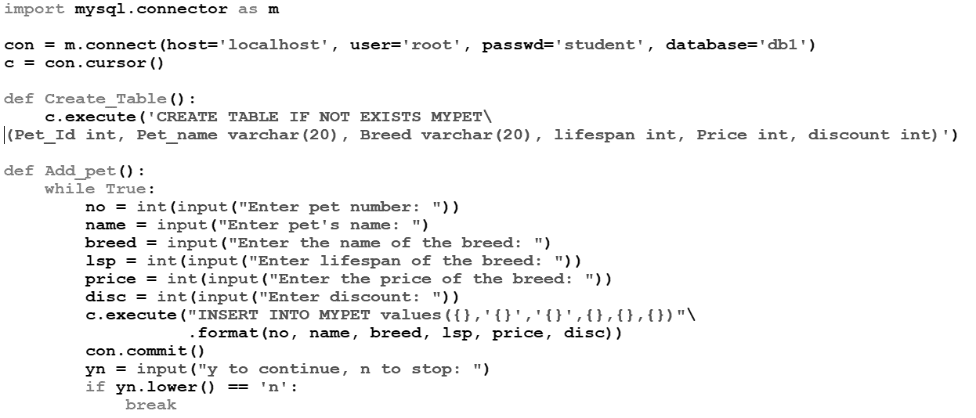
SOURCE CODE:

OUTPUT:
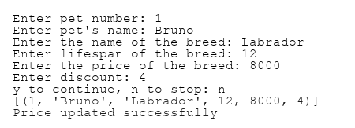
Exp No: 7 Date: 17-06-2026
Aim: Write a program in python for Sql connectivity Consider tables emp and dept tables:
(a) Add a column HRA with default value 2000
(b) Modify HRA for the employee whose empno is input by the user.
(c) Display name, job and annual salary of employees whose comm is assigned in descending order of salary.
(d) Delete the record of employee whose employee number input by the user
(e) Display empno, name, job and department name who are either a manger or a clerk.
(f) Display minimum and maximum, sum and average of salary along with number of records in job
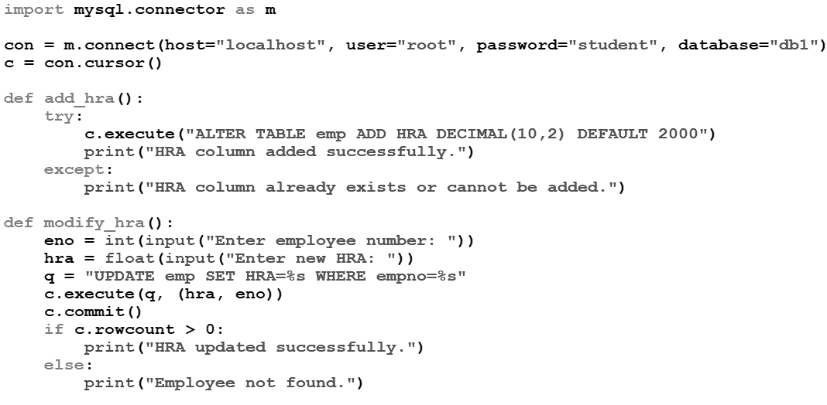
SOURCE CODE:

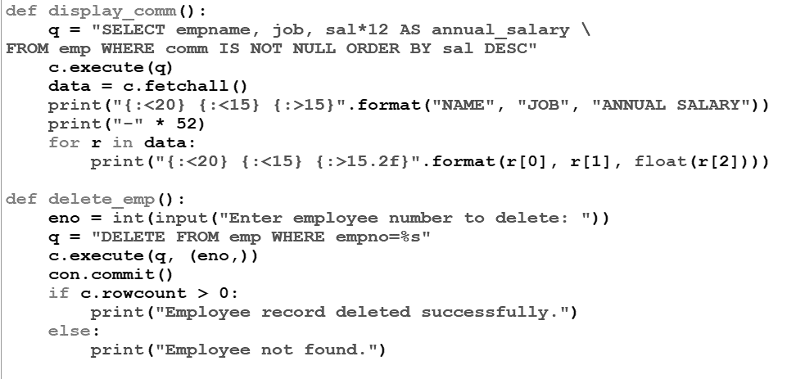

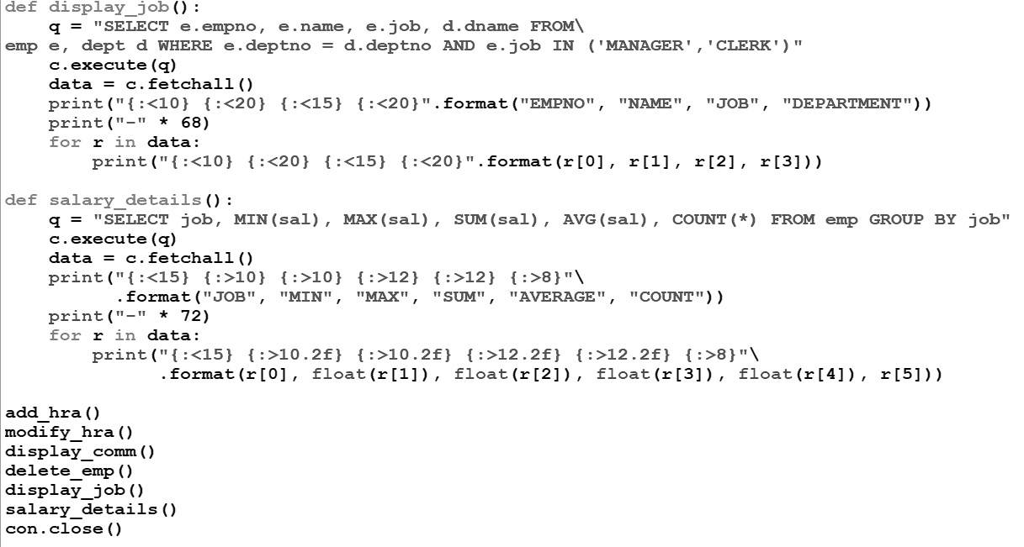
OUTPUT:
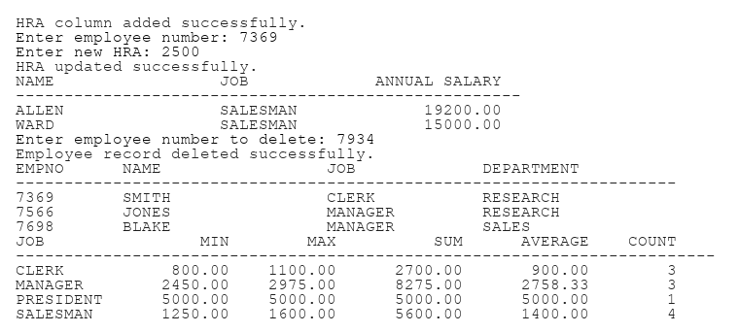
Exp No: 8 Date: 24-06-2026
Aim: Write functions for Python –Sql Connectivity:
(a) List tables in your database
(b) Create Tables – Garment & Fabric. (Tables given qstn 32)
(c)Display the structure of the table Fabric
(d) Insert a Record by accepting values from user
(e) Delete record of a garment with gcode accepted from the user
(f) Modify the price of a garment with specific gcode accepted from user.
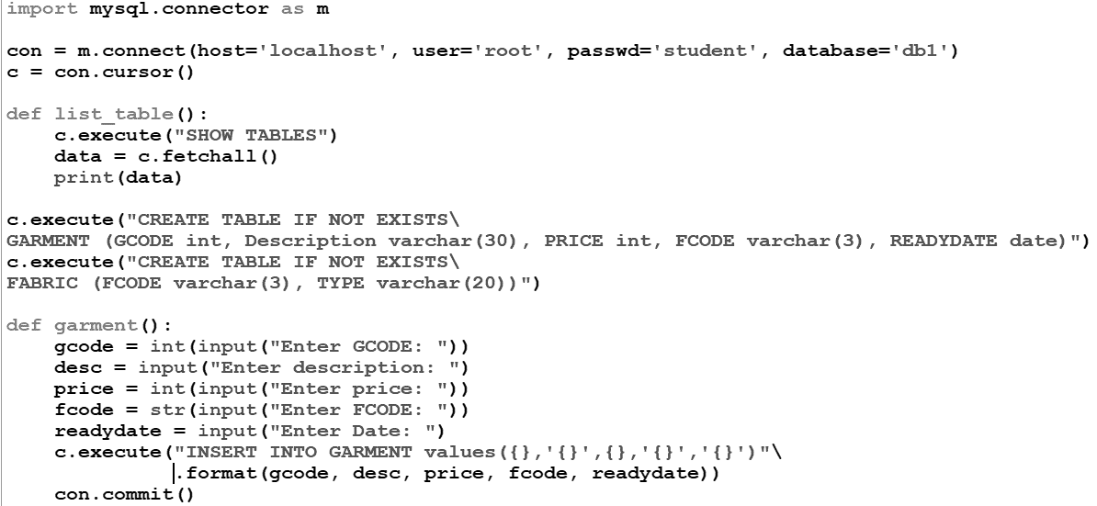
(g) Display records of tables by choice -ie., either records of garment or fabric.
SOURCE CODE:

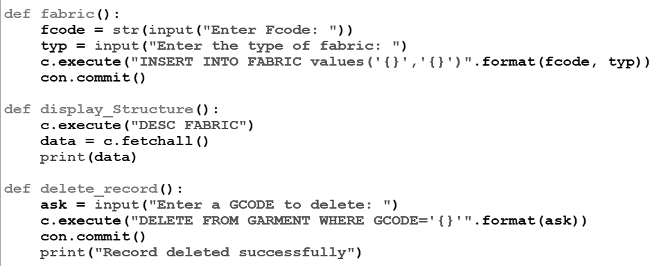

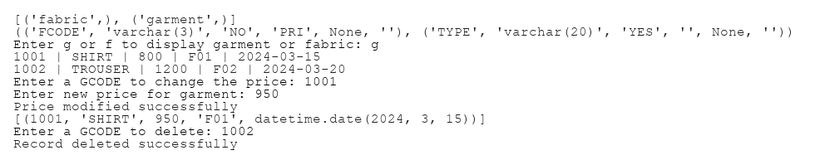
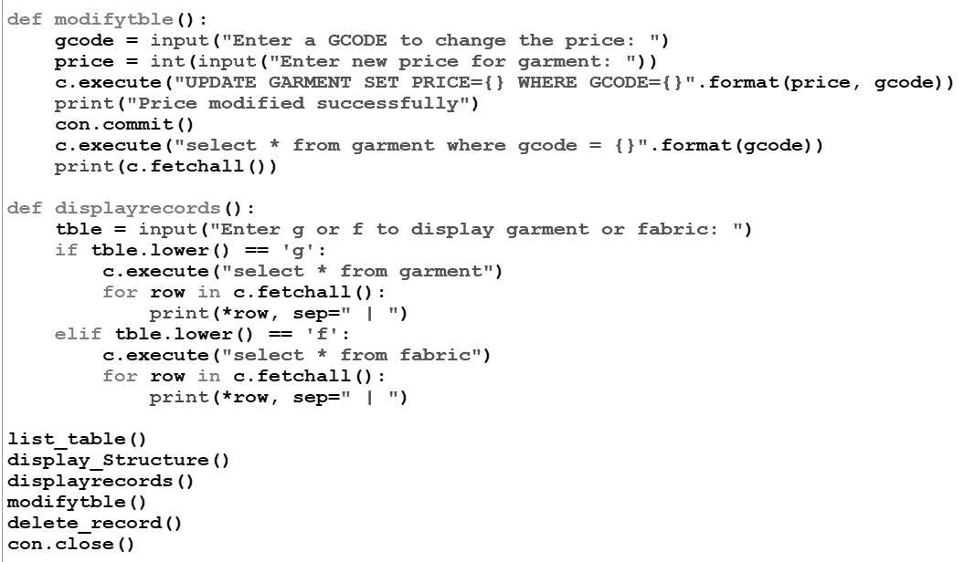
Output
Exp No: 9 Date: 24-06-2026
Aim: A list of names is stored in a text file, Names.txt, (1 name per line) but it contains lot of duplicates. Create a Python function extract_unique_name( ) that extracts all unique names from the text file and stores them in a list and then print the names in alphabetical order.
Sample input file content:
Amithab
Sharuk
Deepika
Prabhas
amithab
DEEPIKA
Expected output:
['amithab', 'deepika', 'prabhas', 'sharuk']
SOURCE CODE:
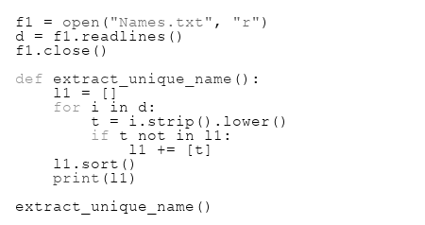
OUTPUT:

Exp No: 10 Date: 24-06-2026
Aim: Write a program with user defined functions
CreateWord(()- to create ‘word.txt’ file – by accepting n of lines of text from user and write it into file using writelines().
DisplayFile()- Display number of characters and number of words in it.
SOURCE CODE:
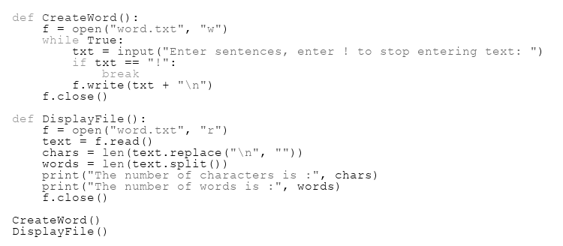
OUTPUT:
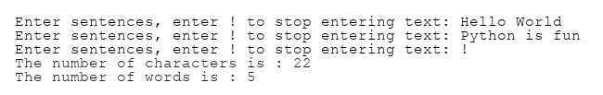
Exp No: 11 Date: 24-06-2026
Aim: Write a program with user defined functions
CreateStory()- n lines accepted from user in a text file story with few lines in it.
DisplayWord()- Display each word separated by a ‘#’
SOURCE CODE:
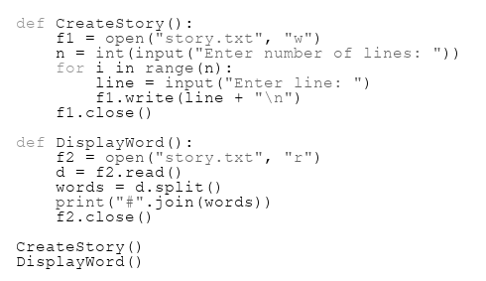
OUTPUT:
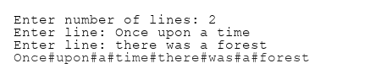

Exp No: 12 Date: 01-07-2026
Aim: Write a program with user defined functions
CreatePledge()- to create pledge.txt, containing few lines of pledge.
DisplayPledge()- Display the contents line by line (after striping leading and trailing whitespaces) along with number of characters in each line
SOURCE CODE:
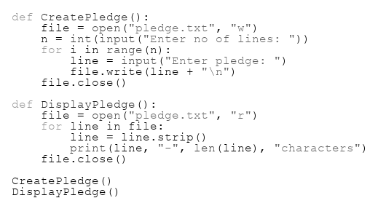
OUTPUT:
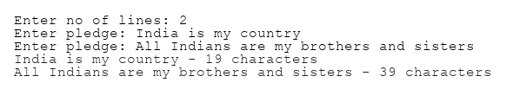

Exp No: 13 Date: 01-07-2026
Aim: Write a program with user defined functions
CreatePoem()- to create the file poem.txt containing the following :
The woods are lovely
dark and deep
But I have promises to keep
And miles to go before I sleep
And miles to go before I sleep (Note: all lines must be user input)
DisplayPoem()- displays the n most commonly occurring words.
SOURCE CODE:
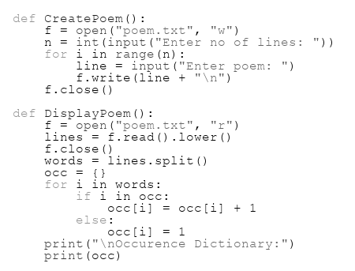
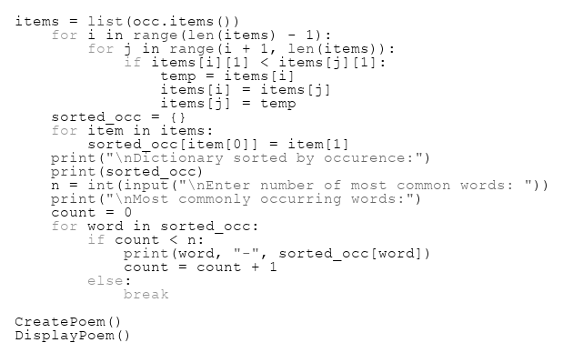

OUTPUT:

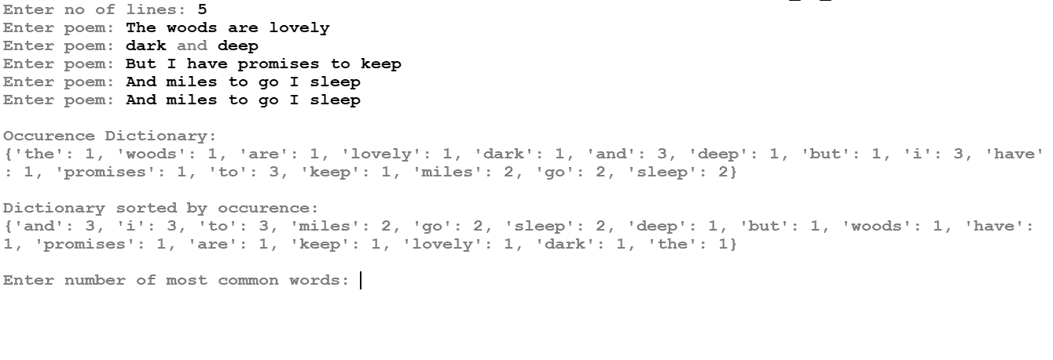
Exp No: 14 Date: 01-07-2026
Aim: Write user-defined functions:
createText() – create the text file wisdom.txt with the following content.
My son, listen to your father's advice.
Don't turn away from your mother's teaching.
What they teach you will be like a beautiful crown on your head.
It will be like a chain to decorate your neck.
(Note: all lines must be user input)
NoVowels() reads the content of the file wisdom.txt and display those words that doesn’t contain any vowels in it.
vowelWord()- reads the content of the file wisdom.txt displays those lines which have the second letter of the first word a vowel.
SOURCE CODE:
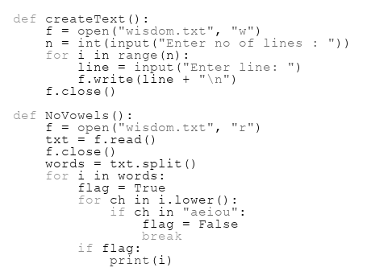
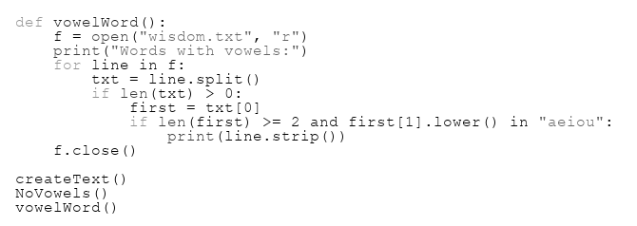
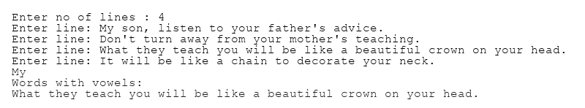
OUTPUT:

Exp No: 15 Date: 01-07-2026
Aim: Write a program with user defined functions
- crtBookFile()- for entering details of books from user and insert it in a binary file named ‘book.det through list.
Sample: [Bookid, Bookname, Authorname, Price]
- BookPrice() –to display book details having price greater than a given price.
- SearchBook()- Sreach and display the details of a specific book entered by user
SOURCE CODE:
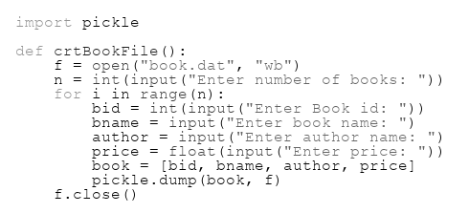
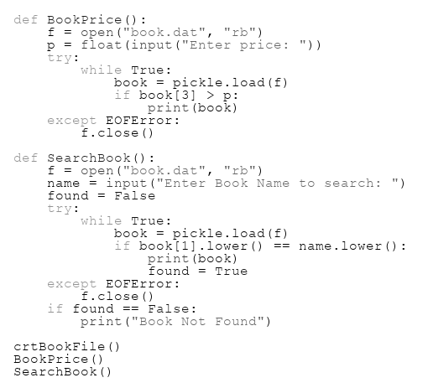
OUTPUT:
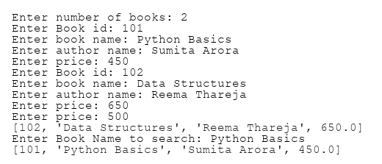

Exp No: 16 Date: 08-07-2026
Aim: Write a user defined function:
- MakeFile () to input multiple items from the user and add to binary file Items.dat which has structure as [Code, Description, Price].
- SearchRec(Code) in Python which will accept the code as parameter and search and display the details of the corresponding code on screen from Items.dat. Also display number items having such code out of total number of items.
SOURCE CODE:
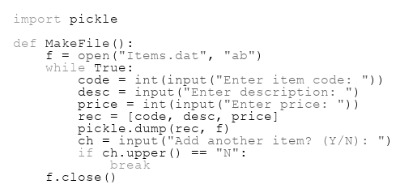
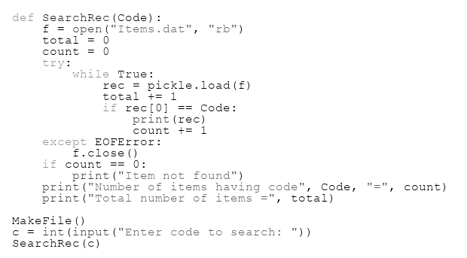
OUTPUT:
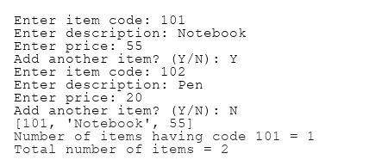

Exp No: 17 Date: 08-07-2026
Aim: Write a program with user defined functions
- CreatEmp()- for entering details of employees from user and insert it in a binary file named ‘emp.dat’ through dictionary. Sample record has the form {empno:[empname,job, sal],
Sample: {101:[Mark,Manager,2000]}
b) DisplayEmps()-Display the records of all employees in tabular form.
c) SearchEmp()-display those employees’ details whose salary is between 25000 and 30000
d) SearchEmpno(eno)- accept the argument and display the record of the employee whose empno is input by the user.
SOURCE CODE:
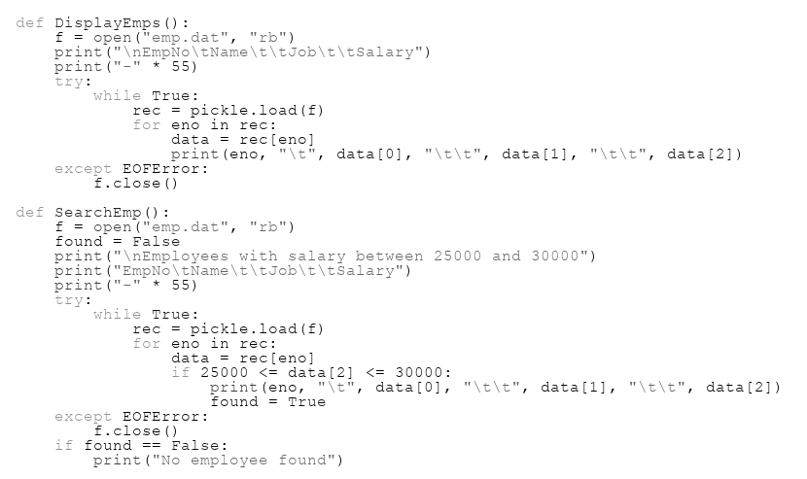
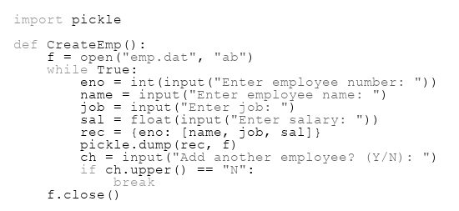

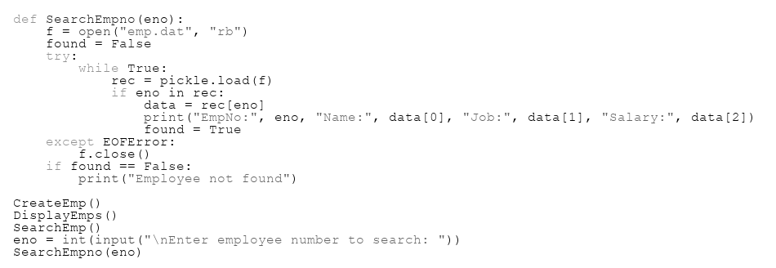
OUTPUT:
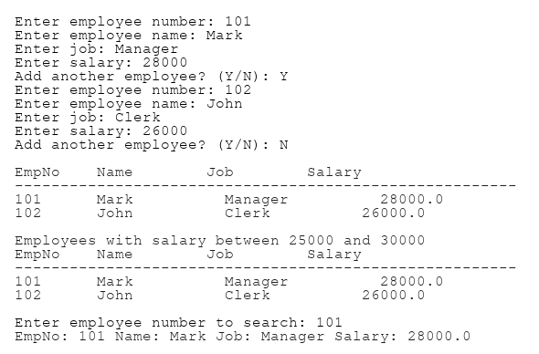

Exp No: 18 Date: 08-07-2026
Aim: A Binary file, CINEMA.DAT has the following structure:
{'MNO':'m101','MNAME':'Sound of Freedom', 'MTYPE':'Thriller']}
Where, MNO – Movie Number; MNAME – Movie Name; MTYPE is Movie Type
Write a user defined function:
createCinema(): that Adds records the user input data into the binary file.
findType(mtype): that accepts mtype as parameter and displays all the records from the binary file CINEMA.DAT, that have the value of Movie Type as mtype.
SOURCE CODE:
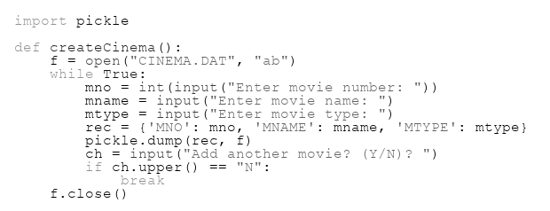
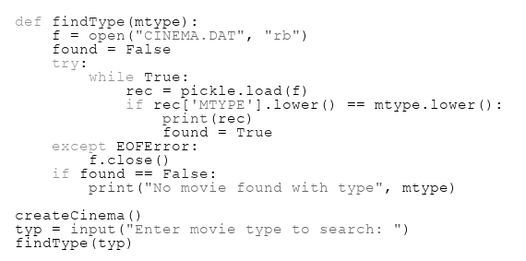
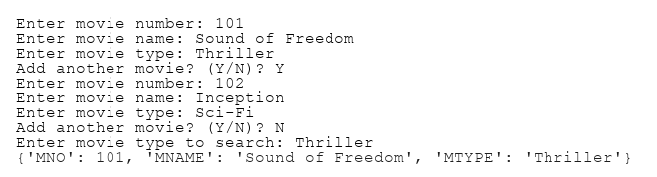
OUTPUT:

Exp No: 19 Date: 08-07-2026
Aim: A file, PASSENGERS. DAT, stores the records of passengers using the following structure:
[PNR, PName, BRDSTN, DESTN, FARE]
where:
PNR - Passenger Number (string type)
PName - Passenger Name (string type)
BRDSTN – Boarding Station Name (string type)
DESTN - Destination Station Name (string type)
FARE - Fare amount for the journey (float type)
Write user defined functions in Python for the following tasks:
    - Create() - to input data for passengers and write it in the binary file PASSENGERS.DAT.
    - SearchDestn(D) - to read contents from the file PASSENGERS.DAT and display the details of those Passengers whose DESTN matches with the value of D.
(iii) UpdateFare () - to increase the fare of all passengers by 5% and rewrite the updated records into the file PASSENGERS. DAT.
(iv) DeleteData() – to delete the details of a passenger whose PNR is input by user.
SOURCE CODE:
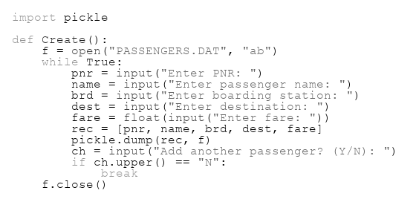
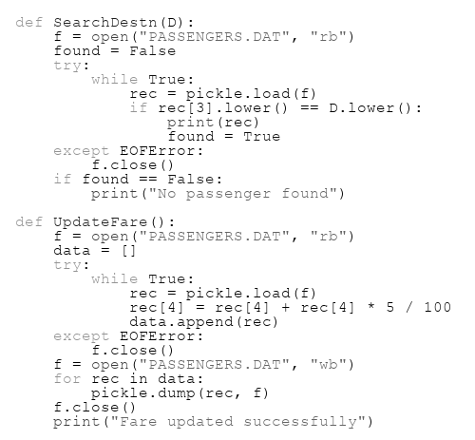
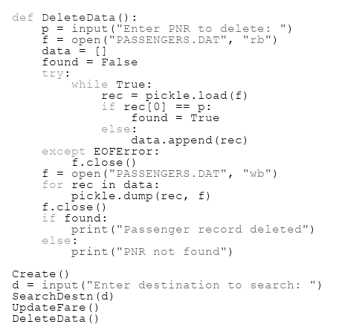
OUTPUT:
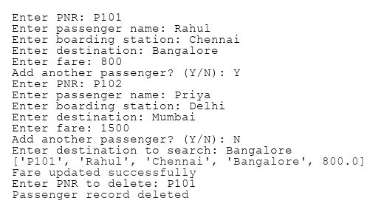

Exp No: 20 Date: 15-07-2026
Aim: Order data (order_id, customer_name, order_date, total_amount) is stored in a binary file named Orders.dat. Each order is represented as a tuple. Help Simran complete the following tasks:
Write user-defined functions:
add_order() - to input order details from the user (order_id, customer_name, order_date, total_amount) and store them in "Orders.dat". The program should allow adding multiple orders until the user chooses to stop.
update_order_amount()- to modify the total_amount-for orders placed. The function should increase the total_amount of each qualifying order by 10%.
SOURCE CODE:
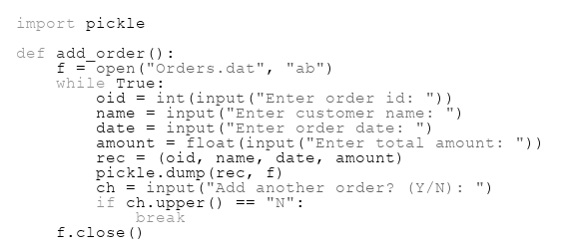
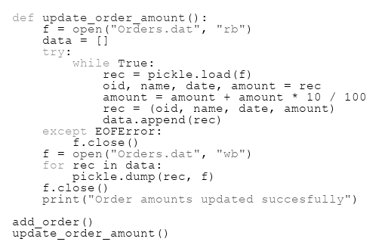
OUTPUT:
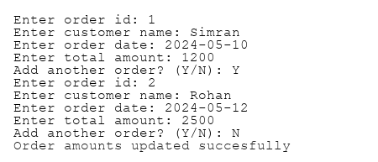

Exp No: 21 Date: 15-07-2026
Aim: Consider book inventory using a CSV file named Inventory.csv.
The file structure is:
[BookID, Title, Author, Available]
where
BookID is an integer
Title and Author are strings
Available is an integer representing the number of copies available.
The librarian needs to write the following functions: -
- add_book(): This function accepts new book details from the user and adds them to `Inventory.csv`. The file should be created with column header if it doesn't exist.
- check_availability(book_id): This function takes a book_id as input and returns the number of copies available for that book. If the book is not found, it should return -1.
SOURCE CODE:
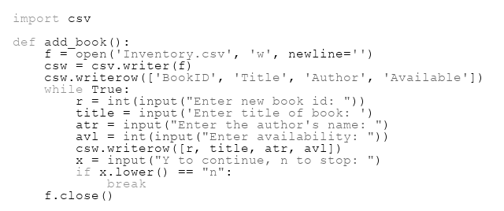
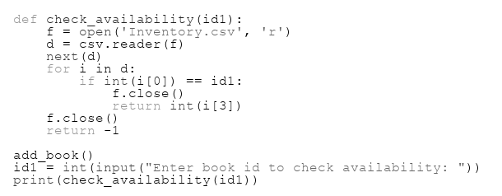
OUTPUT:
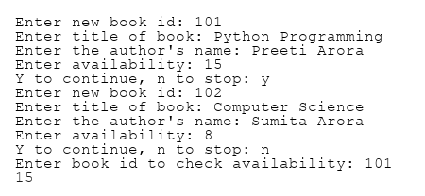

Exp No: 22 Date: 15-07-2026
Aim: Assuming a CSV file students.csv has columns like student_id, name, class,div, subject, score and grade_level. Write the definition of functions to perform the following.
- Add_data( filename ) :- accepts a file name as argument and reads input from user and store data into the file as per format specified.
- Display_data(filename) :- accepts a filename as argument and reads data from file. Function also reads subject name, class and div as input from user. Displays the average score by the student for the subject in the class specified.
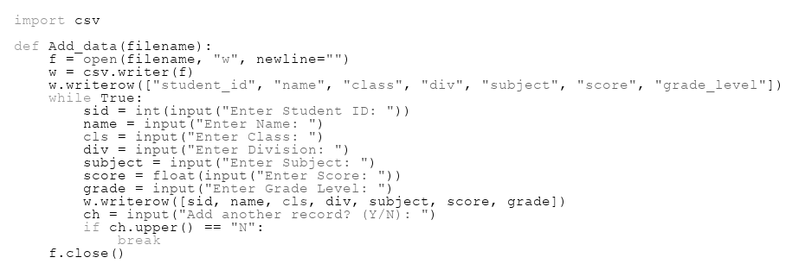
SOURCE CODE:
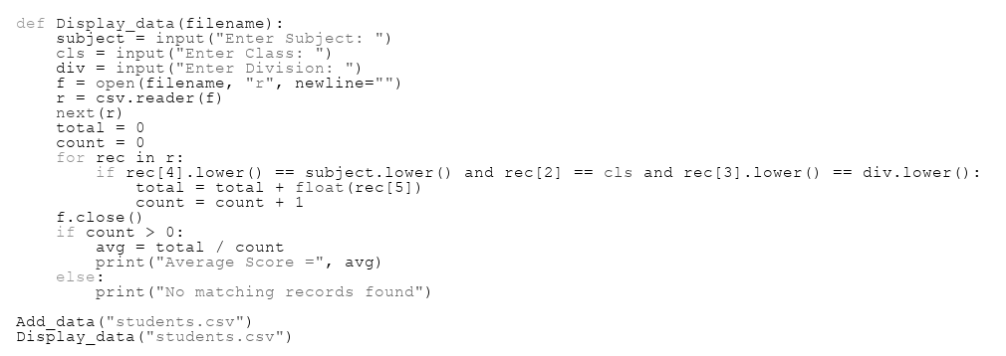
OUTPUT:
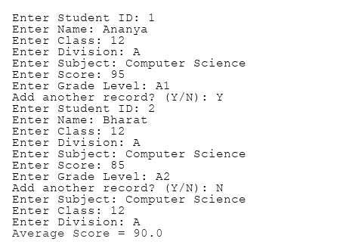

Exp No: 23 Date: 22-07-2026
Aim: Anil created a csv file named gadgets.csv to store the details of the gadgets
The structure of gadgets.csv is:
[Deviceno, Name, Price, Brand] - Where, Deviceno is device ID (integer), Name is device name (string), Price is device price (integer), Brand is device brand (string)
He is now instructed to write the following functions to perform the required operations on csv files.
Newgadget() -to add the details of new gadgets in csv file gadget.csv which stores records in the format. Deviceno, name, price, brand. Get the input from the user.
Countgadget() - to read the csv file „gadget.csv‟ and display the details of the devices whose price in the range 1000 to 2500. Also, display the number of such devices.
SOURCE CODE:
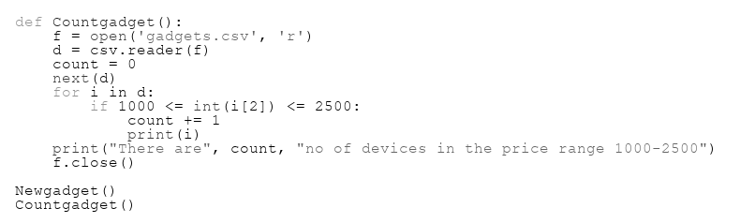
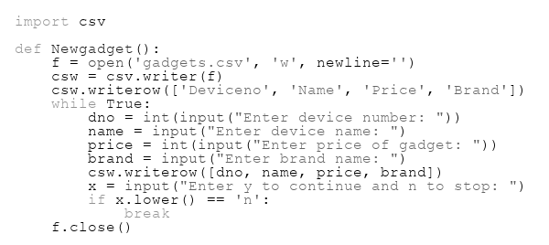

OUTPUT:
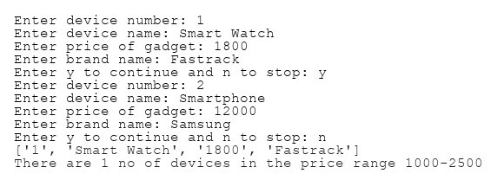

Exp No: 24 Date: 22-07-2026
Aim: Samantha, a software developer at a company, is tasked with managing a database for employee performance reviews. She has created a CSV file named "Performance.csv" to store the data. The structure of "Performance.csv" is as follows:
[Emp_Id, Emp_Name, Project_Name, Review_Result]
Where:
Emp_Id - employee ID (integer)
Emp_Name - employee name (string)
Project_Name - name of the project for the performance review (string)
Review_Result - result of the review, which can be 'Excellent', 'Satisfactory', or 'Needs Improvement'
Samantha needs to implement the following user-defined functions to efficiently handle the data:
accept_record() - This function should accept a record from the user, including employee ID, employee name, project name, and review result, and add it to the "Performance.csv" file. The column headings should also be added on top of the CSV file.
excellent_count() - Samantha wants a function to count the number of employees who received an 'Excellent' review for any project. Help Samantha by providing Python code for these user-defined functions
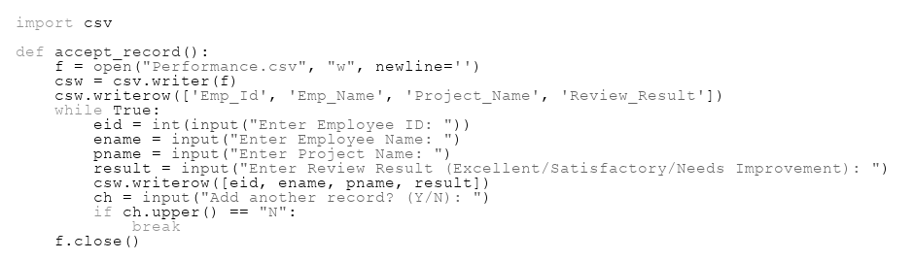
SOURCE CODE:
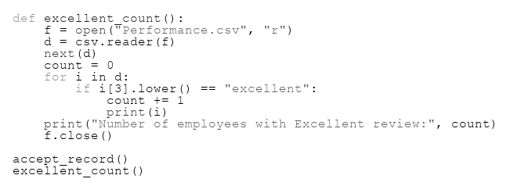

OUTPUT:
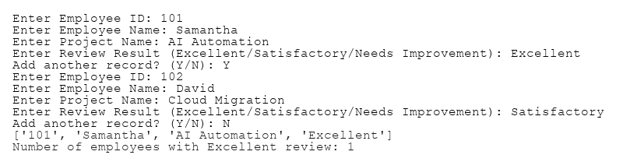

Exp No: 25 Date: 22-07-2026
Aim: Write a Python menu driven program to implement a stack (LIFO) using a list data structure.
A linear stack called Books contains the following information:
[BookNumber, name of the book and cost of the book]
- PUSH(Books,N) method in python to add N book details each containing the above mentioned information’s.
- DispStack()- display the stack content in same line
- POP(Book)- pop and display all the elements of the stack and Under Flow when no more elements to be popped.
SOURCE CODE:
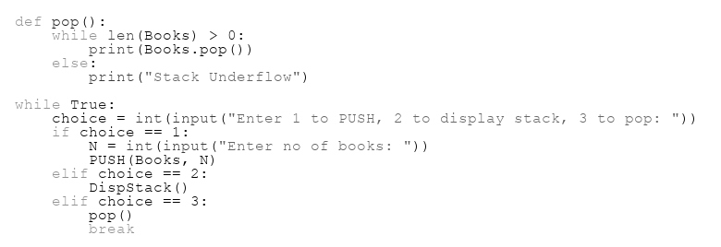
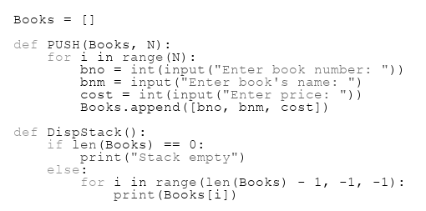

OUTPUT:
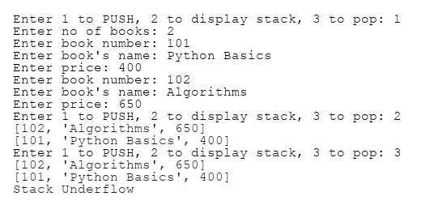
Exp No: 26 Date: 22-07-2026
Aim: A list of dictionaries contact contains the following information:
{Eid:[Ename, Phno,Salary]} of Employee
Write a Python menu driven program to implement a stack (LIFO) using a list data structure, stack status :
PUSH ( ) - To Push an object containing Phone number of Employee and Name of Employee into the stack.
POP( ) - To Pop an object from the stack and to release the memory
Display() – display details of all Employees
SOURCE CODE:
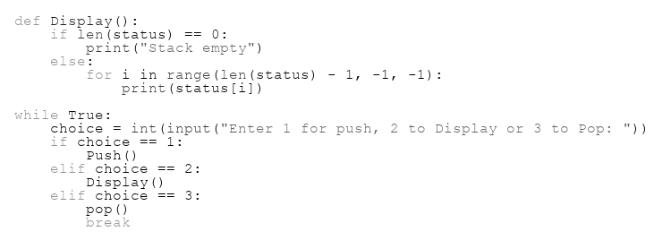
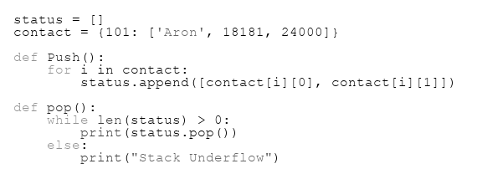

OUTPUT:
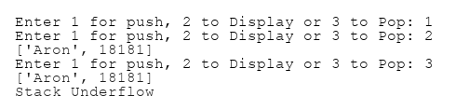

Exp No: 27 Date: dd-mm-yyyy
Aim: Write a function in Python where Book is a stack implemented by a list of books:
(i) PushBook() - to add a new book entry as a record – ie. (book_no, book_title) of Books , considering it to act as push operations of the Stack data structure.
(ii) Disp_Stack() – display details of all books
Bookno: Booktitle one after other in different lines
(iii) PopBook() – display a record removed from the stack in the following format:
Bookno: Booktitle
SOURCE CODE:
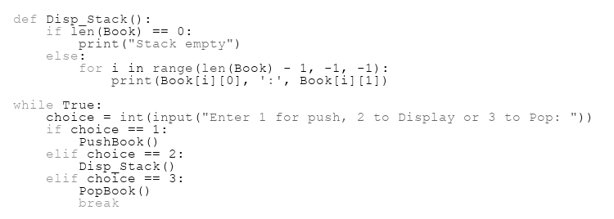
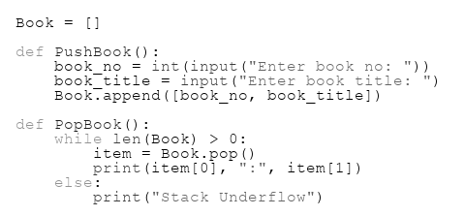

OUTPUT:
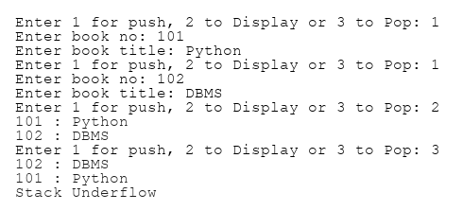

Exp No: 28 Date: dd-mm-yyyy
Aim: Julie has created a dictionary containing names and marks as key value pairs of 6 students. Write a program, with separate user defined functions to perform the following operations:
● PUSH(R)-Push the keys (name of the student) of the dictionary into a stack, where the corresponding value (marks) is greater than 75.
● POP()- Pop and display the content of the stack with ‘Under flow’ message when there are no more elements to be popped.
For example: If the sample content of the dictionary is as follows:
R={"OM":76, "JAI":45, "BOB":89, "ALI":65, "ANU":90, "TOM":82}
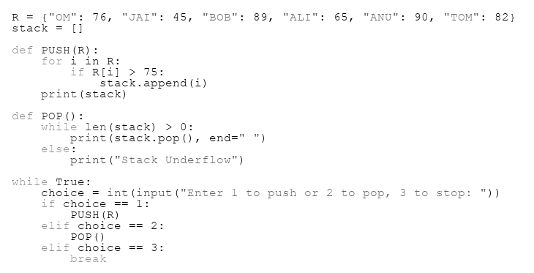
SOURCE CODE:

OUTPUT:
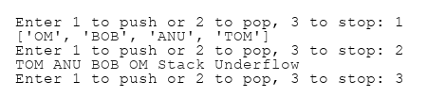
Exp No: 29 Date: dd-mm-yyyy
Aim: Andrew has a list containing 10 integers. You need to help him create a program with separate user defined functions to perform the following operations based on this list.
● PUSHNums(N)- Traverse the content of the list and push the even numbers into a stack.
● PopNums()- pop and display the content of the stack.
For Example: If the sample Content of the list is as follows:
N=[12, 13, 34, 56, 21, 79, 98, 22, 35, 38]
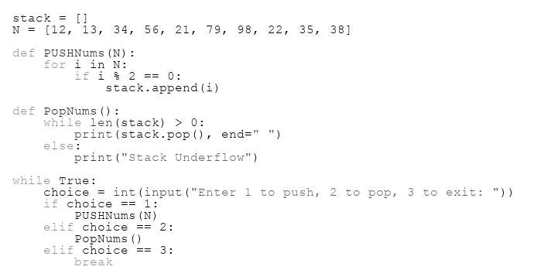
SOURCE CODE:

OUTPUT:
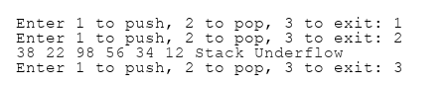
Exp No: 30 Date: dd-mm-yyyy
Aim: Write a function in Python, where Arr is a stack implemented by a list of numbers:
(i) PUSH(L), where L is a list of numbers. From this list push all numbers divisible by 5 into a stack implemented by using a list.
(ii) Display the stack if it has at least one element, otherwise display appropriate error
(iii) POP(), pop and returns top element when ever it is called, returns ‘UnderFlow’ if the stack is empty.
SOURCE CODE:
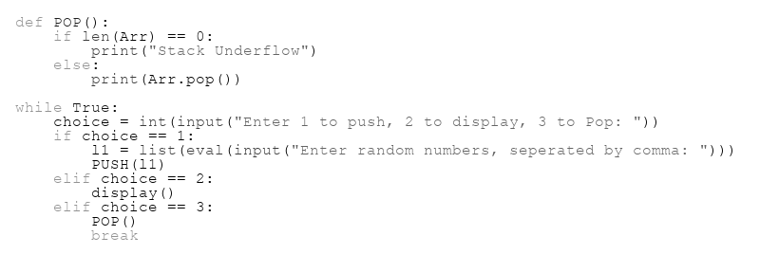
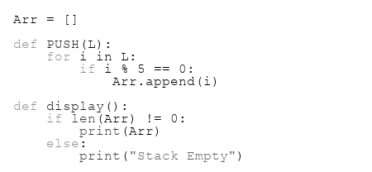

OUTPUT:
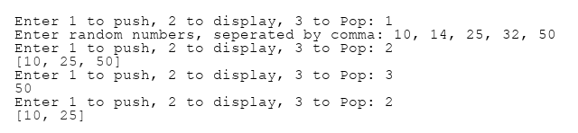

Exp No: 31 Date: dd-mm-yyyy
Aim: Consider tables Garment and Fabric.
Table: Fabric
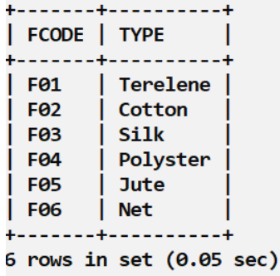

Table: Garment
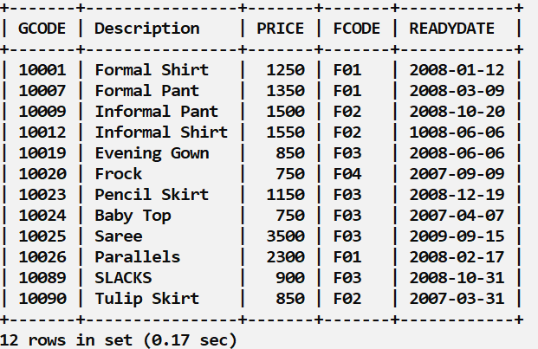

a) Display min, max, sum, and average price for each fabric codes in table Garment.
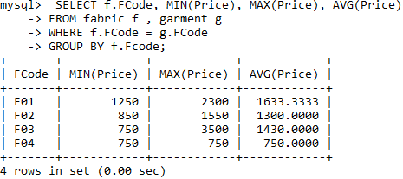

b) Find the total number of garments in each Type.

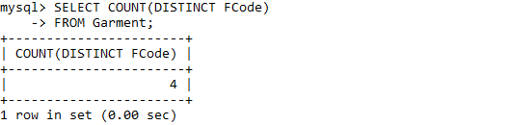

c) Increase the price of ‘SLACKS’ by 150.

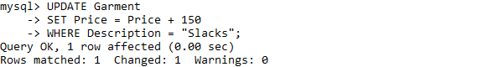

d) Display fabric code, description, price and type of all garments
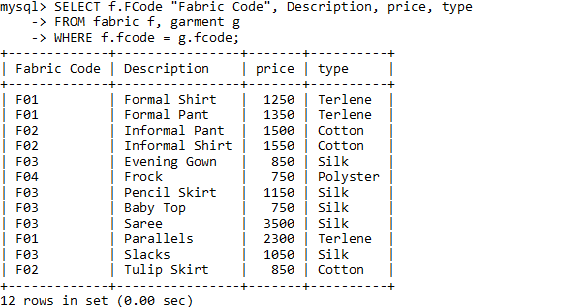

e) Display Maximum Fabric code, minimum Ready date.

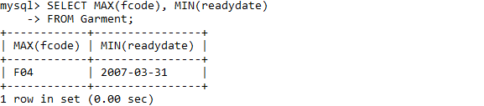

f)Display different Fabric codes.

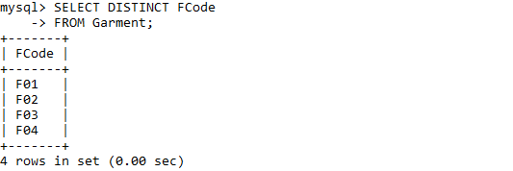

g)Display number of different Fabric codes.

h) Display the name of garments whose length contains less than 7 characters.

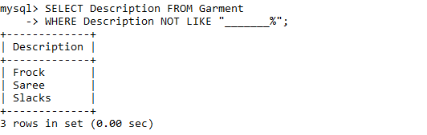

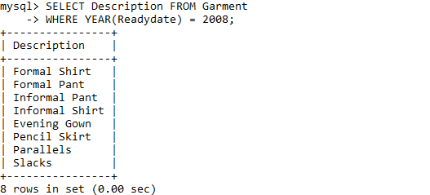
i) Display the name of fabrics ready in 2008.

j)Display Equi-join

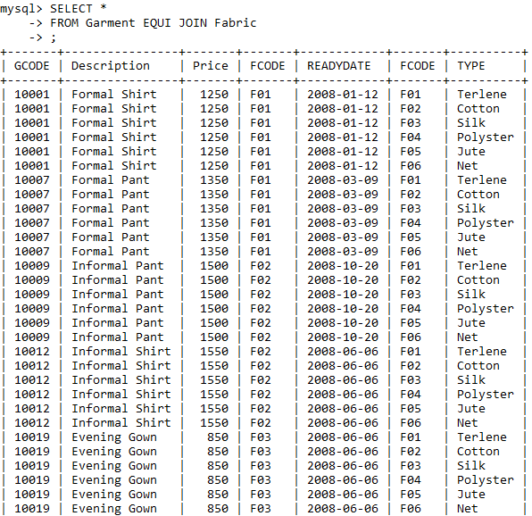

k)Display natural join.

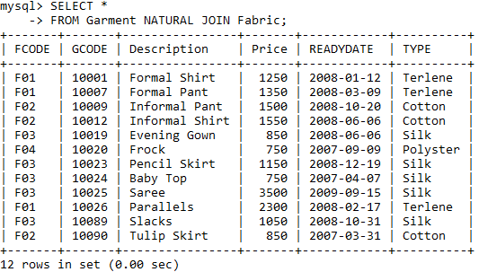

Exp No: 32 Date: dd-mm-yyyy
Aim: Consider the table Student
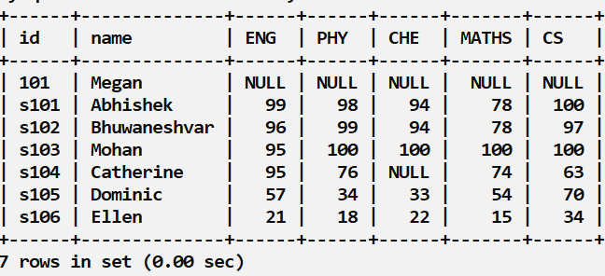

- Modify the id 101 as s107
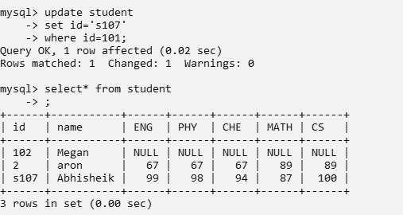
- Add column Tot
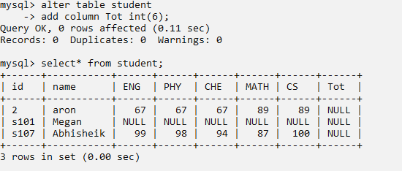

c) Modify the values in column Tot as sum of all subjects (ie., Eng+Phy+Che+Maths+CS) using query.
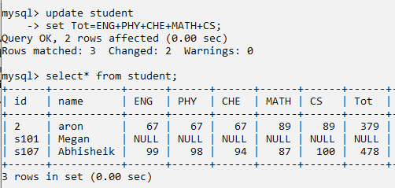
d) Add columns Average and Grade.
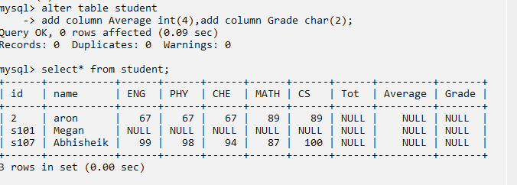
e) Modify the values in column Average with Tot/5, assign A+ in column Grade for those students whose average mark greater than 91. (using Queries)
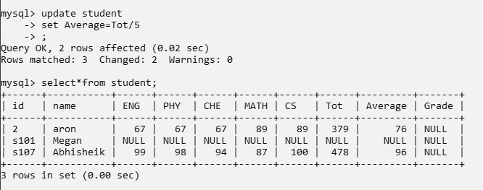
f) Delete the details of a student in the table whose Tot mark is not assigned.

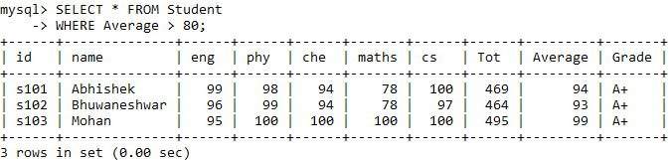
g)Display the details of the students whose average mark more than 80.

h)Display the min, max, sum, and average of CS marks.

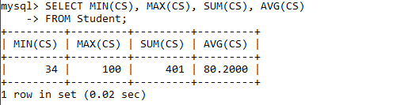

i)Display student ID, Name &marks arranged in descending order of the Average mark.

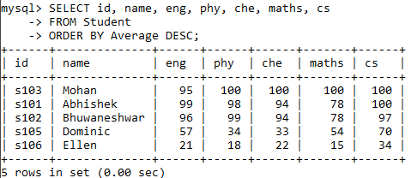

j)Add the record - 's104','Catherine', 95,76, NULL, 74, 63.

k)Change Che =80 and Grade =’A’ for the student with id s104.

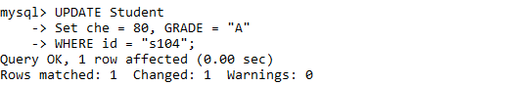

Exp No: 33 Date: dd-mm-yyyy
Aim: Consider Tables EMP and Dept
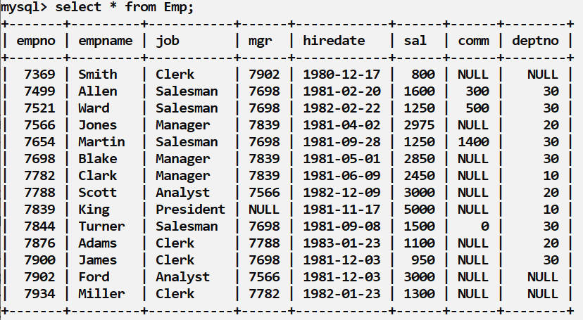

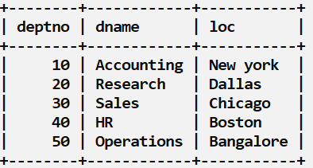

- Increase the salary of all employees by a factor of 100.
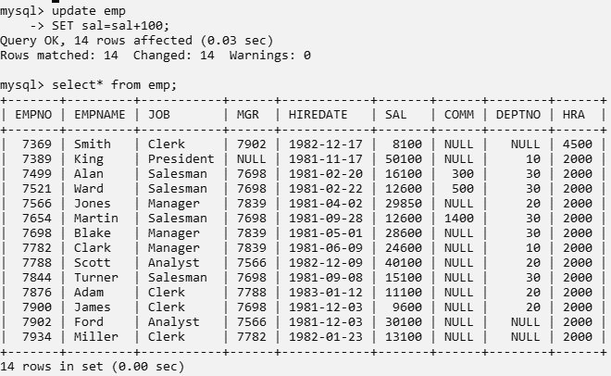

- Display number of employees, sum and average salary in each department from tables Emp and Dept.
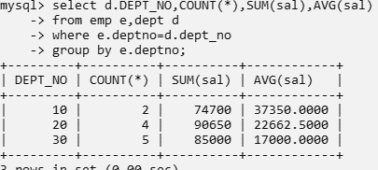
- Display Empno, Empname, and Deptno & Dname from tables Emp and Dept.
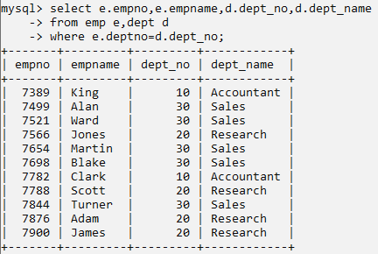
- Display number of employees, sum and average salary in each job.
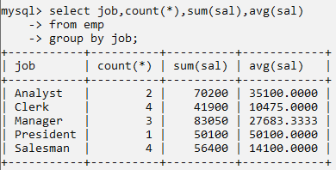
- Display number of employees, sum and average salary in each job where number of employees less than 2.
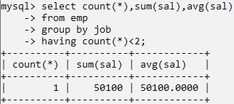

f) Display the Name and joining date of senior most employee
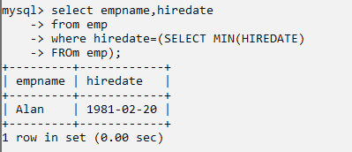

g) Display minimum salary and last hiring date
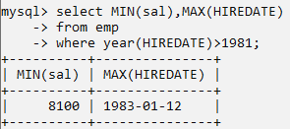
h) Display average commission from the table Employee.
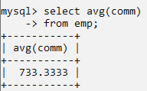
i) Display different jobs.
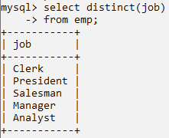
j) Display number of different jobs.
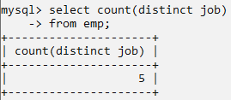

Exp No: 34 Date: dd-mm-yyyy
Aim: Consider Tables: Flights & Fares
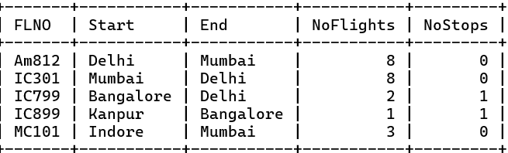
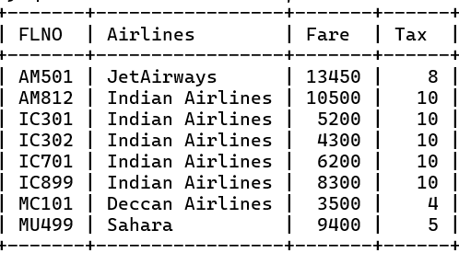
Write commands to display:
- Fl_No and No_Flights from Kanpur to Bangalore.

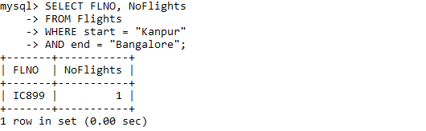

- Arrange the contents of flights in descending order of Fl_No.

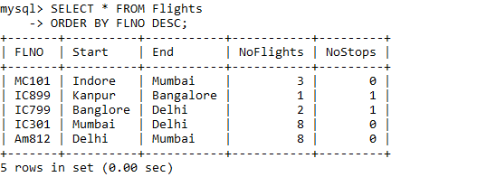

- Display Fl_No, Airlines and Fare to be paid for the flights from Delhi to Mumbai from tables flights and Fares where Fare to be paid=Fare+ Fare* Tax/100.

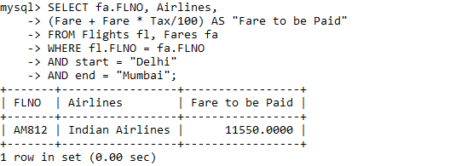

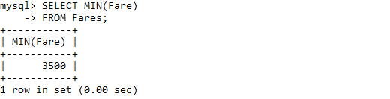
- Minimum fare Indian Airlines offering from table Fares.
Exp No: 35 Date: dd-mm-yyyy
Aim: Consider Tables : Employee & Department.
Table : Employee
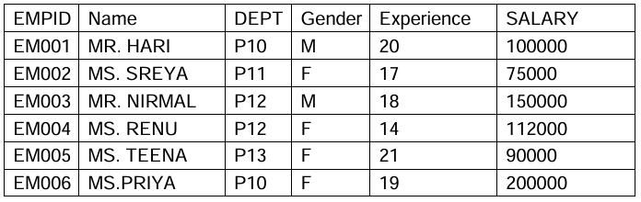
Table: Department
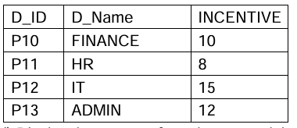
- Display the names of employees and the name of the department they are in.
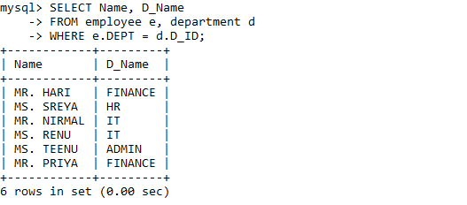

- Display the number of male and female employees in each department.

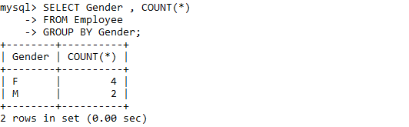

- Display the number of employees having more than 15 yrs of experience and earning more than 100000.

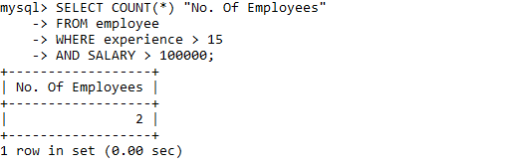

- Display the name of the employees and the incentive that they will get incentive column has the values in percentage. The values that should be displayed is the calculated value of the percentage on the salary.

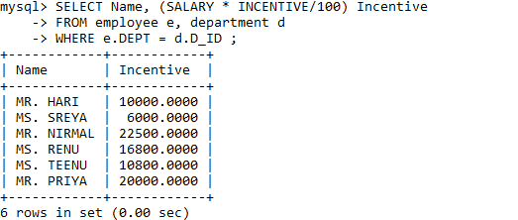

- Display the total salary of each employee along with the name of the employee which is salary + incentive(calculate percentage on the salary)
